* **Introduction**

Java Bank Management System, the most important factor in selecting the Java programming language was its impressively high level of protection against hacking. The majority of businesses in the banking sector employ the java spring boot idea, which is utilized for high-level security. The bank management system Project is an application for maintaining a person’s account in a bank. It is used to keep the records of clients, employees, and others in the bank. Moreover, the system allows customers to create accounts, deposit/withdraw money from their accounts, and examine reports for all of their accounts. The system’s specification is shown in the following presentation.

* Information about SQL access and Intellij idea

A simple and basic level little project for learning purposes is an online **Bank Management System Project in Java**. It’s written in Java and uses MySQL as a database, it is used to develop unique identity number giving access to database. By the help of IDE of java Intellij idea IntelliJ IDEA is an integrated development environment written in Java for developing computer software written in Java, Kotlin, Groovy, and other JVM-based languages. It is developed by JetBrains and is available as an Apache 2 Licensed community edition, and in a proprietary commercial edition. To connect Java application with the MySQL database, we need to follow 5 following steps.

we are using MySql as the database. So we need to know following informations for the mysql database:

**Driver class:** The driver class for the mysql database is **com.mysql.jdbc.Driver**.

**Connection URL:** The connection URL for the mysql database is **jdbc:mysql://localhost:3306/sonoo** where jdbc is the API, mysql is the database, localhost is the server name on which mysql is running, we may also use IP address, 3306 is the port number and sonoo is the database name. We may use any database, in such case, we need to replace the sonoo with our database name.

**Username:** The default username for the mysql database is **root**.

**Password:** It is the password given by the user at the time of installing the mysql database. In this example, we are going to use 123456 as the password.

* **Screen Shots of design form and database connectivity**

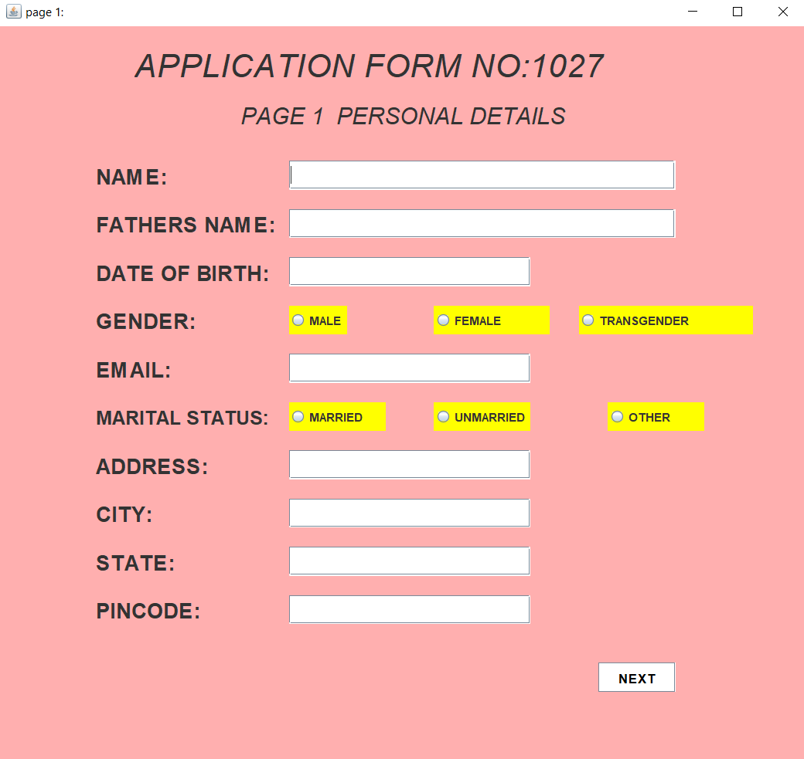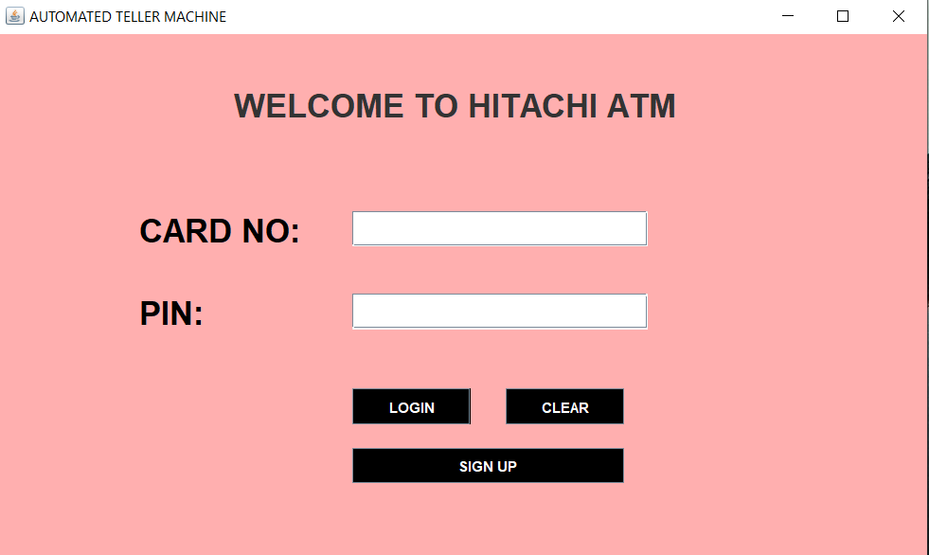

**LOGIN FRAME**

**SIGN UP ONCE PAGE**

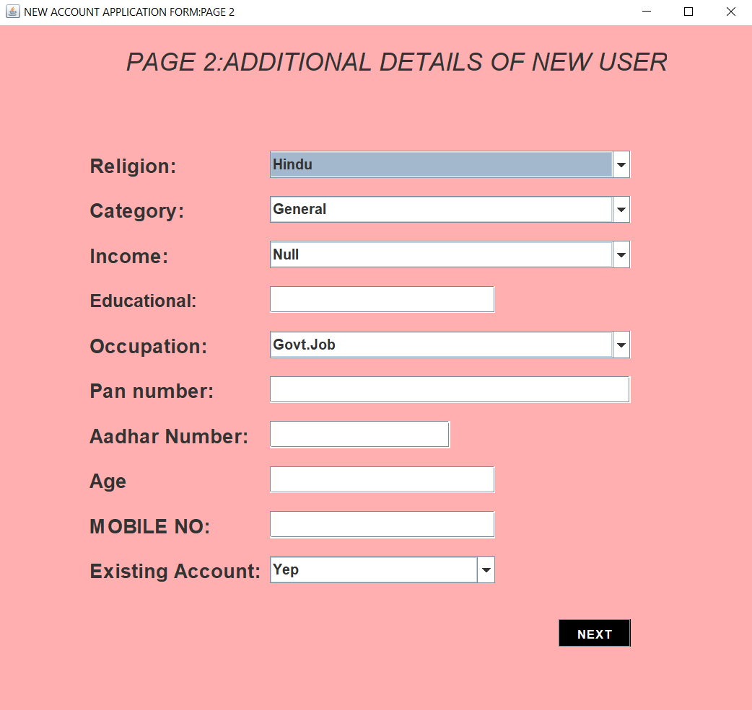

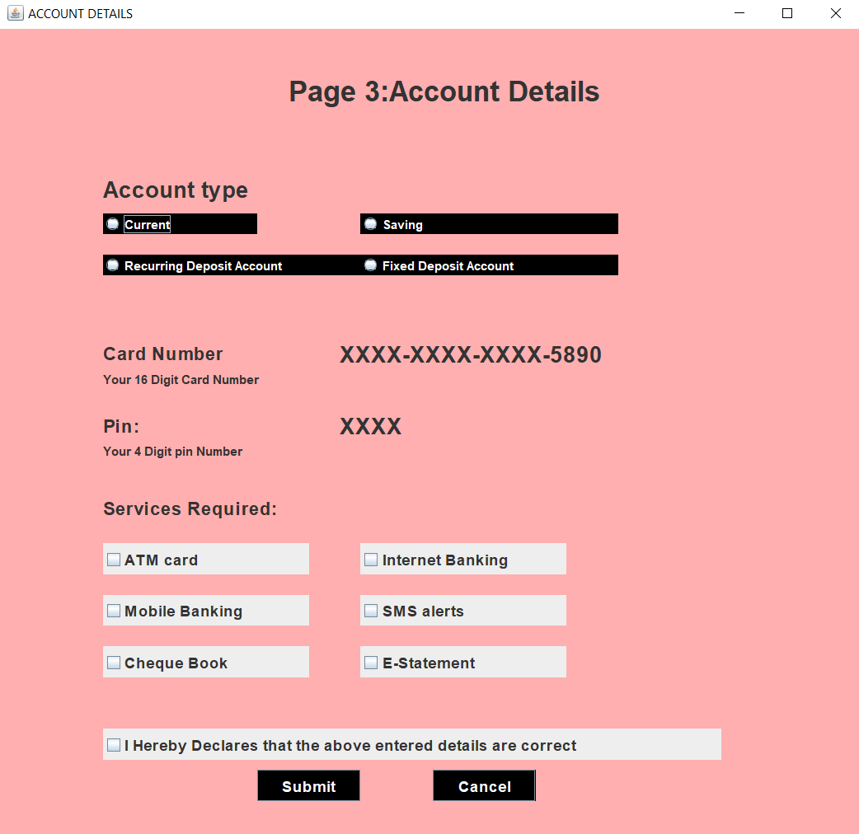

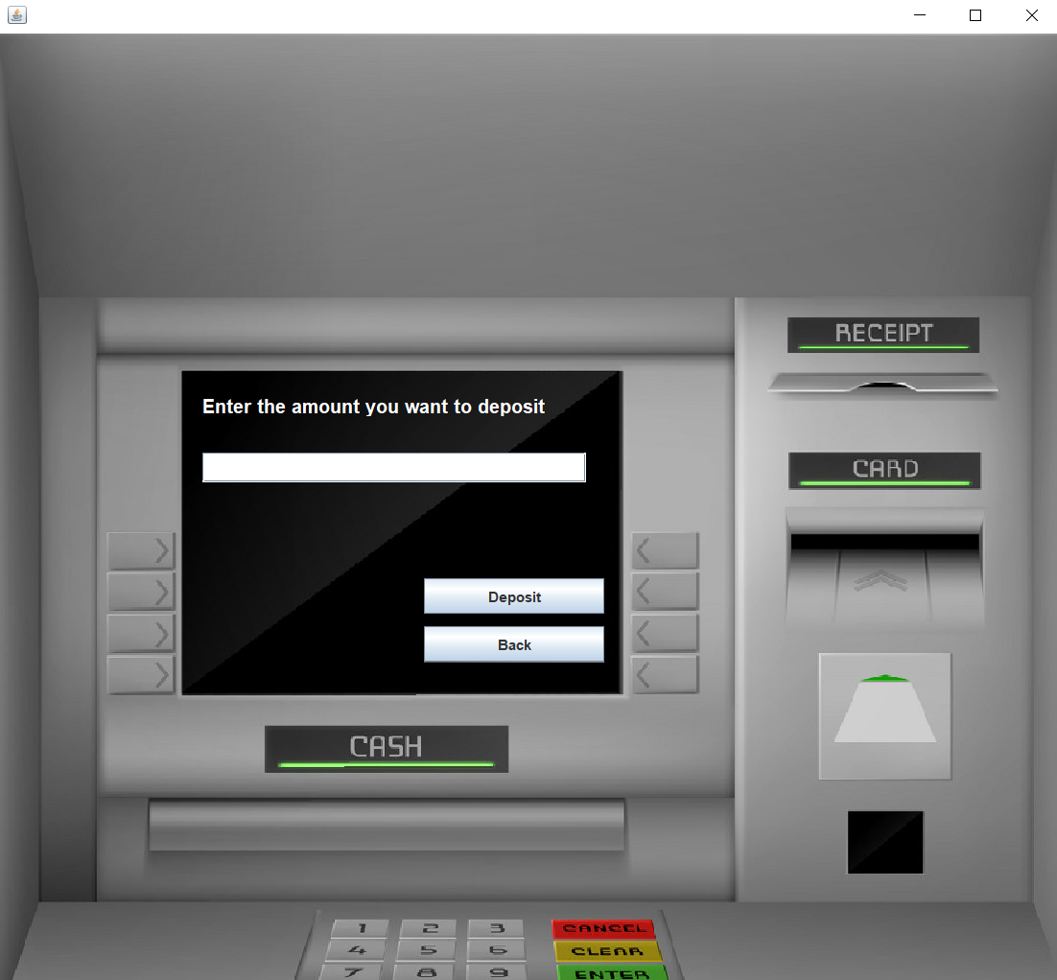

**DEPOSIT INTERFACE**

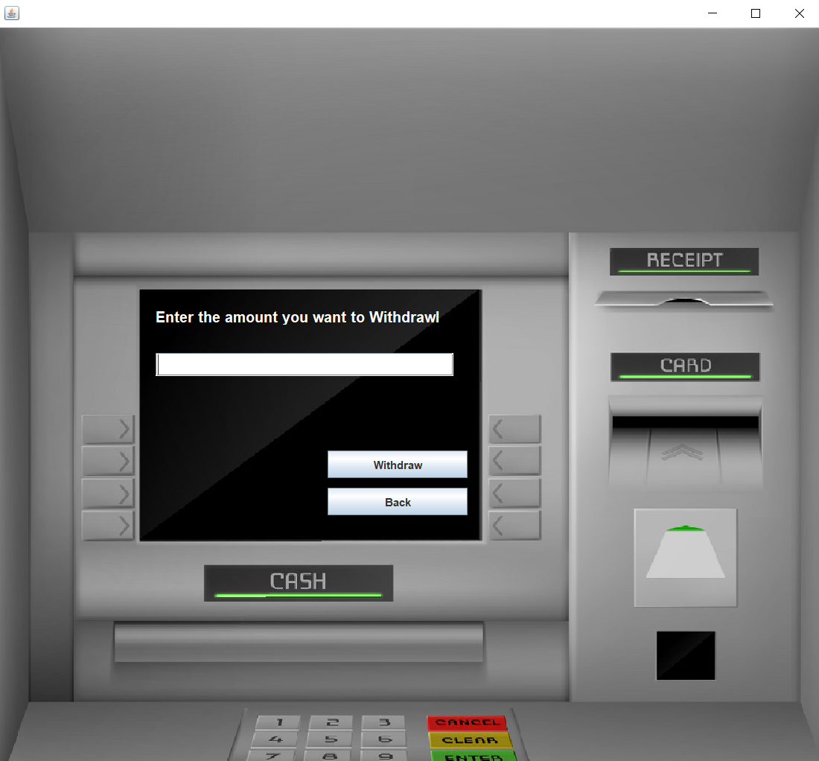

**WITHDRAWAL INTERFACE**

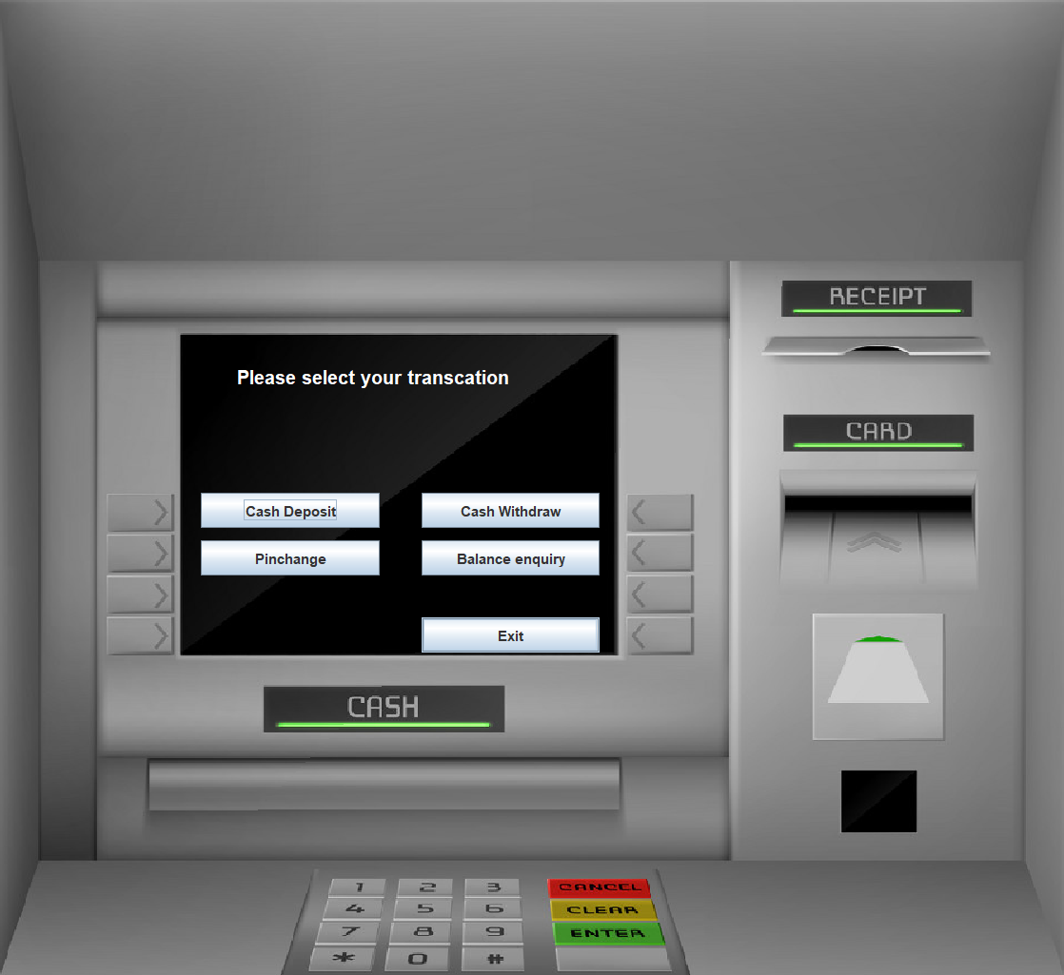

**TRANSCTION INTERFACE**

* **SQL Connectivity**

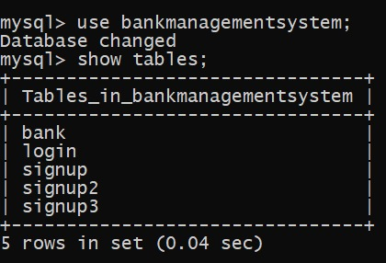

* 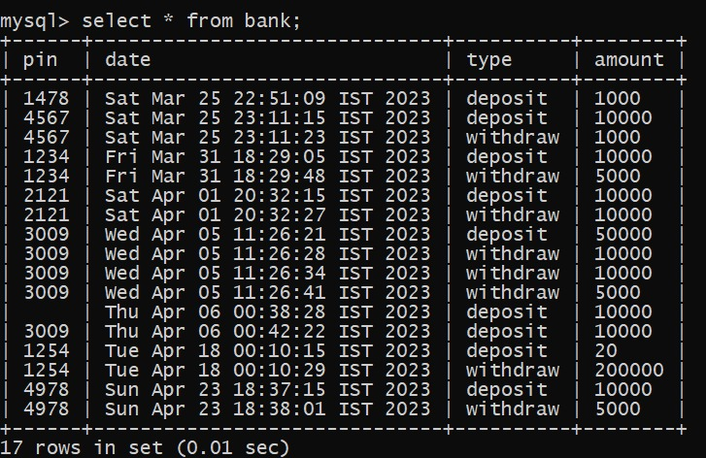**CODING**

1. **LOGIN CLASS**

import javax.swing.*;  
import javax.swing.text.StyledEditorKit;  
import java.awt.*;  
import java.awt.event.*;  
import java.sql.ResultSet;  
  
public class Login extends JFrameimplements ActionListener {  
JButtonlogin, signup, clear;  
JTextFieldcardTextField;  
JPasswordFieldpinTextField;  
Login() {  
setTitle("AUTOMATED TELLER MACHINE");  
setLayout(null);  
  
JLabel text = new JLabel("WELCOME TO HITACHI ATM");  
text.setFont(new Font("osward", Font.*BOLD*, 28));  
text.setBounds(200, 40, 400, 40);  
add(text);  
  
JLabelcardno = new JLabel("CARD NO:");  
cardno.setFont(new Font("osward", Font.*BOLD*, 28));  
cardno.setForeground(Color.*black*);  
cardno.setBounds(120, 150, 150, 30);  
add(cardno);  
cardTextField= new JTextField();  
cardTextField.setFont(new Font("Raleway",Font.*BOLD*,16));  
cardTextField.setBounds(300, 150, 250, 30);  
add(cardTextField);  
  
JLabel pin = new JLabel("PIN:");  
pin.setFont(new Font("Raleway", Font.*BOLD*, 28));  
pin.setForeground(Color.*black*);  
pin.setBounds(120, 220, 230, 30);  
add(pin);  
  
pinTextField= new JPasswordField();  
pinTextField.setBounds(300, 220, 250, 30);  
pinTextField.setFont(new Font("arial",Font.*BOLD*,16));  
add(pinTextField);  
  
login = new JButton("LOGIN");  
login.setBounds(300, 300, 100, 30);  
login.setBackground(Color.*BLACK*);  
login.setForeground(Color.*WHITE*);  
login.addActionListener(this);  
add(login);  
  
clear = new JButton("CLEAR");  
clear.setBounds(430, 300, 100, 30);  
clear.setBackground(Color.*BLACK*);  
clear.setForeground(Color.*WHITE*);  
clear.addActionListener(this);  
add(clear);  
  
signup = new JButton("SIGN UP");  
signup.setBounds(300, 350, 230, 30);  
signup.setBackground(Color.*BLACK*);  
signup.setForeground(Color.*WHITE*);  
signup.addActionListener(this);  
add(signup);  
  
getContentPane().setBackground(Color.*pink*);  
setSize(800, 480);  
setVisible(true);  
setLocation(350, 200);  
}  
public void actionPerformed(ActionEvent ae)  
 { if(ae.getSource() == clear)  
 {  
cardTextField.setText("");  
pinTextField.setText("");  
}  
else if(ae.getSource()==login)  
{ Conn conn=new Conn();  
String cardnumber=cardTextField.getText();  
String pinnumber=pinTextField.getText();  
String query="select* from login where cardnumber='"+cardnumber+"'and pin='"+pinnumber+"'";  
 try {  
ResultSetrp = conn.s.executeQuery(query);  
 if (rp.next()) {  
setVisible(false);  
 new Transactions(pinnumber).setVisible(true);  
} else {  
JOptionPane.*showMessageDialog*(null, "Incorrect cardnumber or pin");  
}  
 }  
catch(Exception e)  
{System.*out*.println(e);  
}  
 }  
else if (ae.getSource()==signup)  
 {  
setVisible(false);  
 new SignupOne().setVisible(true);  
}  
 }  
public static void main(String[]args)  
 {  
new Login().setVisible(true);  
}  
}

1. **SIGN UP ONCE CLASS**

import javax.swing.*;  
import java.awt.*;  
import java.util.*;  
import java.awt.event.*;

public class SignupOneextends JFrameimplements ActionListener {  
long random;  
JTextFieldnameTextField,fnameTextField,dobTextField,emailTextField,addressTextField,cityTextField,stateTextField,pincodeTextField;  
JButtonnext;  
JRadioButton male,female,transgender,married,unmarried,other;  
SignupOne()  
 {

setLayout(null);  
  
Random ran=new Random();  
random=Math.*abs*((ran.nextLong()%9000L)+1000L);  
setTitle("page 1:");  
  
JLabelformno=new JLabel("APPLICATION FORM NO:"+random);  
formno.setFont(new Font("Raleway",Font.*ITALIC*,34));  
formno.setBounds(140,20,600,40);  
add(formno);  
  
JLabelPersonalDetails=new JLabel("PAGE 1 PERSONAL DETAILS");  
PersonalDetails.setFont(new Font("Raleway",Font.*ITALIC*,24));  
PersonalDetails.setBounds(250,80,400,26);  
add(PersonalDetails);  
  
JLabel name=new JLabel("NAME:");  
name.setFont(new Font("Raleway",Font.*BOLD*,22));  
name.setBounds(100,140,100,30);  
add(name);  
  
nameTextField= new JTextField();  
nameTextField.setBounds(300, 140, 400, 30);  
nameTextField.setFont(new Font("arial",Font.*BOLD*,16));  
add(nameTextField);  
  
JLabelfname=new JLabel("FATHERS NAME:");  
fname.setFont(new Font("Raleway",Font.*BOLD*,22));  
fname.setBounds(100,190,200,30);  
add(fname);  
  
fnameTextField= new JTextField();  
fnameTextField.setBounds(300, 190, 400, 30);  
fnameTextField.setFont(new Font("arial",Font.*BOLD*,16));  
add(fnameTextField);  
  
JLabel dob=new JLabel("DATE OF BIRTH:");  
dob.setFont(new Font("Raleway",Font.*BOLD*,22));  
dob.setBounds(100,240,200,30);  
add(dob);  
  
dobTextField= new JTextField();  
dobTextField.setBounds(300, 240, 250, 30);  
dobTextField.setFont(new Font("arial",Font.*BOLD*,16));  
add(dobTextField);  
  
JLabel gender=new JLabel("GENDER:");  
gender.setFont(new Font("Raleway",Font.*BOLD*,22));  
gender.setBounds(100,290,200,30);  
add(gender);  
  
male=new JRadioButton("MALE");  
male.setBounds(300,290,60,30);  
male.setBackground(Color.*yellow*);  
add(male);  
  
female=new JRadioButton("FEMALE");  
female.setBounds(450,290,120,30);  
female.setBackground(Color.*yellow*);  
add(female);  
  
transgender=new JRadioButton("TRANSGENDER");  
transgender.setBounds(600,290,180,30);  
transgender.setBackground(Color.*yellow*);  
add(transgender);  
  
ButtonGroupgendergroup=new ButtonGroup();  
gendergroup.add(male);  
gendergroup.add(female);  
gendergroup.add(transgender);  
  
JLabel email=new JLabel("EMAIL:");  
email.setFont(new Font("Raleway",Font.*BOLD*,22));  
email.setBounds(100,340,200,30);  
add(email);  
  
emailTextField= new JTextField();  
emailTextField.setBounds(300, 340, 250, 30);  
emailTextField.setFont(new Font("arial",Font.*BOLD*,16));  
add(emailTextField);  
  
JLabel marital=new JLabel("MARITAL STATUS:");  
marital.setFont(new Font("Raleway",Font.*BOLD*,20));  
marital.setBounds(100,390,200,30);  
add(marital);  
  
married=new JRadioButton("MARRIED");  
married.setBounds(300,390,100,30);  
married.setBackground(Color.*yellow*);  
add(married);  
  
unmarried=new JRadioButton("UNMARRIED");  
unmarried.setBounds(450,390,100,30);  
unmarried.setBackground(Color.*yellow*);  
add(unmarried);  
  
other=new JRadioButton("OTHER");  
other.setBounds(630,390,100,30);  
other.setBackground(Color.*yellow*);  
add(other);  
  
ButtonGroupmartialgroup=new ButtonGroup();  
martialgroup.add(married);  
martialgroup.add(unmarried);  
martialgroup.add(other);  
  
  
JLabel address=new JLabel("ADDRESS:");  
address.setFont(new Font("Raleway",Font.*BOLD*,22));  
address.setBounds(100,440,200,30);  
add(address);  
  
addressTextField= new JTextField();  
addressTextField.setBounds(300, 440, 250, 30);  
addressTextField.setFont(new Font("arial",Font.*BOLD*,16));  
add(addressTextField);  
  
JLabel city=new JLabel("CITY:");  
city.setFont(new Font("Raleway",Font.*BOLD*,22));  
city.setBounds(100,490,200,30);  
add(city);  
  
cityTextField= new JTextField();  
cityTextField.setBounds(300, 490, 250, 30);  
cityTextField.setFont(new Font("arial",Font.*BOLD*,16));  
add(cityTextField);  
  
JLabel state=new JLabel("STATE:");  
state.setFont(new Font("Raleway",Font.*BOLD*,22));  
state.setBounds(100,540,200,30);  
add(state);  
  
stateTextField= new JTextField();  
stateTextField.setBounds(300, 540, 250, 30);  
stateTextField.setFont(new Font("arial",Font.*BOLD*,16));  
add(stateTextField);  
  
JLabelpincode=new JLabel("PINCODE:");  
pincode.setFont(new Font("Raleway",Font.*BOLD*,22));  
pincode.setBounds(100,590,200,30);  
add(pincode);  
  
pincodeTextField= new JTextField();  
pincodeTextField.setBounds(300, 590, 250, 30);  
pincodeTextField.setFont(new Font("arial",Font.*BOLD*,16));  
add(pincodeTextField);  
  
  
next=new JButton("NEXT");  
next.setBackground(Color.*white*);  
next.setForeground(Color.*black*);  
next.setFont(new Font("Raleway",Font.*BOLD*,14));  
next.setBounds(620,660,80,30);  
next.addActionListener(this);  
add(next);  
  
  
getContentPane().setBackground(Color.*pink*);  
  
  
setSize(850,800);  
setLocation(350,10);  
setVisible(true);  
}  
public void actionPerformed(ActionEvent ae)  
 {  
 String formno="" +random;//long  
String name=nameTextField.getText();//setText  
String fname=fnameTextField.getText();  
String dob=dobTextField.getText();  
String gender=null;  
 if(male.isSelected())  
 {  
 gender="Male";  
}  
else if (female.isSelected())  
 {  
 gender="Female";  
}  
else if (transgender.isSelected())  
 {  
 gender="Transgender";  
}  
 String email=emailTextField.getText();  
String marital=null;  
 if(married.isSelected())  
 {  
 marital="Married";  
} else if (unmarried.isSelected())  
 {  
 marital="Unmarried";  
} else if (other.isSelected())  
 {  
 marital="Other";  
}  
 String address=addressTextField.getText();  
String city=cityTextField.getText();  
String state=stateTextField.getText();  
String pincode=pincodeTextField.getText();  
try{  
if(name.equals(""))//use for mandatory  
{  
JOptionPane.showMessageDialog(null,"Name is Mandatory");  
}  
else if (fname.equals(""))  
 {  
JOptionPane.showMessageDialog(null,"FATHERS NAME is Mandatory");  
}  
else if (dob.equals(""))  
 {  
JOptionPane.showMessageDialog(null,"Date of birth IS Mandatory");  
}  
  
else if (email.equals(""))  
 {  
JOptionPane.*showMessageDialog*(null,"email IS Mandatory");  
}  
else if (address.equals(""))  
 {  
JOptionPane.*showMessageDialog*(null,"email IS Mandatory");  
}  
else if (city.equals(""))  
 {  
JOptionPane.*showMessageDialog*(null,"city IS Mandatory");  
}  
else if (state.equals(""))  
 {  
JOptionPane.*showMessageDialog*(null,"state IS Mandatory");  
}  
else if (pincode.equals(""))  
 {  
JOptionPane.*showMessageDialog*(null,"pincode is mandatory");  
}  
else  
{  
 Conn c=new Conn();  
String query="insert into signup values('"+formno+"','"+name+"','"+fname+"','"+dob+"','"+gender+"','"+email+"','"+marital+"','"+city+"','"+state+"','"+pincode+"')";  
c.s.executeUpdate(query);  
  
setVisible(false);  
 new SignupTwo(formno).setVisible(true);  
}  
}  
catch(Exception e)  
{  
System.out.println(e);  
}  
 }  
public static void main(String[]args)  
 {  
new SignupOne();  
}  
}

1. **CONNECTION CLASS**

import java.sql.*;  
public class Conn  
{  
 Connection c;  
Statement s;  
  
 public Conn()  
 {  
try  
{  
//use for jdbc connectivity  
c=DriverManager.*getConnection*("jdbc:mysql:///bankmanagementsystem","root","123456");//use for connection  
s=c.createStatement();  
}  
catch (Exception e)  
 {  
 System.*out*.println(e);  
}  
  
 }

1. **SIGN UP TWO CLASS**

import javax.swing.*;  
import java.awt.*;  
import java.awt.event.ActionEvent;  
import java.awt.event.ActionListener;  
  
public class SignupTwo extends JFrame implements ActionListener {  
  
  
JTextFieldeducationTextField,panTextField,AadharTextField,agetextfield,mobiletextfield;  
JButton next;  
JComboBox religion,category,income,Existing_Account,Occupation;  
String formno;  
SignupTwo(String formno)  
 {  
this.formno=formno;  
setLayout(null);  
  
setTitle("NEW ACCOUNT APPLICATION FORM:PAGE 2");  
  
JLabel additiondetails=new JLabel("PAGE 2:ADDITIONAL DETAILS OF NEW USER");  
additiondetails.setFont(new Font("Raleway",Font.*ITALIC*,28));  
additiondetails.setBounds(140,20,600,40);  
add(additiondetails);  
  
JLabel name=new JLabel("Religion:");  
name.setFont(new Font("Raleway",Font.*BOLD*,22));  
name.setBounds(100,140,100,30);  
add(name);  
  
String valreligion[]={"Hindu","sikh","Muslim","Christian","Other"};  
religion=new JComboBox<>(valreligion);  
religion.setFont(new Font("arial",Font.*BOLD*,16));  
religion.setBackground(Color.*white*);  
religion.setBounds(300, 140, 400, 30);  
add(religion);  
  
  
JLabel fname=new JLabel("Category:");  
fname.setFont(new Font("Raleway",Font.*BOLD*,22));  
fname.setBounds(100,190,150,30);  
add(fname);  
  
String valcategory[]={"General","Obc","Sc","St","Other"};  
category=new JComboBox<>(valcategory);  
category.setFont(new Font("arial",Font.*BOLD*,16));  
category.setBackground(Color.*white*);  
category.setBounds(300, 190, 400, 30);  
add(category);  
  
JLabel income1=new JLabel("Income:");  
income1.setFont(new Font("Raleway",Font.*BOLD*,22));  
income1.setBounds(100,240,200,30);  
add(income1);  
  
String incomecategory[]={"Null","<1,50,000","<3,50,000","<6,50,000",">6,50,000"};  
income=new JComboBox<>(incomecategory);  
income.setFont(new Font("arial",Font.*BOLD*,16));  
income.setBackground(Color.*white*);  
income.setBounds(300, 240, 400, 30);  
add(income);  
  
JLabel education=new JLabel("Educational:");  
education.setFont(new Font("Raleway",Font.*BOLD*,20));  
education.setBounds(100,290,200,30);  
add(education);  
  
educationTextField= new JTextField();  
educationTextField.setBounds(300, 290, 250, 30);  
educationTextField .setFont(new Font("arial",Font.*BOLD*,16));  
add(educationTextField);  
  
JLabel marital=new JLabel("Occupation:");  
marital.setFont(new Font("Raleway",Font.*BOLD*,22));  
marital.setBounds(100,340,250,30);  
add(marital);

String occupationcategory[]={"Govt.Job","Farmer","Business Man","Private Job","Other"};  
Occupation=new JComboBox<>(occupationcategory);  
Occupation.setFont(new Font("arial",Font.*BOLD*,16));  
Occupation.setBackground(Color.*white*);  
Occupation.setBounds(300, 340, 400, 30);  
add(Occupation);  
  
JLabel pan=new JLabel("Pan number:");  
pan.setFont(new Font("Raleway",Font.*BOLD*,22));  
pan.setBounds(100,390,200,30);  
add(pan);  
  
panTextField= new JTextField();  
panTextField.setBounds(300, 390, 400, 30);  
panTextField .setFont(new Font("arial",Font.*BOLD*,16));  
add(panTextField);  
  
JLabel Aadhar=new JLabel("Aadhar Number:");  
Aadhar.setFont(new Font("Raleway",Font.*BOLD*,22));  
Aadhar.setBounds(100,440,200,30);  
add(Aadhar);  
  
AadharTextField= new JTextField();  
AadharTextField.setBounds(300, 440, 200, 30);  
AadharTextField .setFont(new Font("arial",Font.*BOLD*,16));  
add(AadharTextField);  
  
  
JLabel age=new JLabel("Age");  
age.setFont(new Font("Raleway",Font.*BOLD*,22));  
age.setBounds(100,490,250,30);  
add(age);  
  
agetextfield=new JTextField();  
agetextfield.setBounds(300, 490, 250, 30);  
agetextfield.setFont(new Font("arial",Font.*BOLD*,16));  
add(agetextfield);  
  
  
JLabel mobile=new JLabel("MOBILE NO:");  
mobile.setFont(new Font("Raleway",Font.*BOLD*,22));  
mobile.setBounds(100,540,250,30);  
add(mobile);  
  
mobiletextfield=new JTextField();  
mobiletextfield.setBounds(300,540,250,30);  
mobiletextfield.setFont(new Font("Raleway",Font.*BOLD*,22));  
add(mobiletextfield);  
  
JLabel pin=new JLabel("Existing Account:");  
pin.setFont(new Font("Raleway",Font.*BOLD*,22));  
pin.setBounds(100,590,300,30);  
add(pin);  
  
String pincategory[]={"Yep","Nope"};  
Existing_Account =new JComboBox<>(pincategory);  
Existing_Account.setFont(new Font("arial",Font.*BOLD*,16));  
Existing_Account.setBackground(Color.*white*);  
Existing_Account.setBounds(300, 590, 250, 30);  
add(Existing_Account);  
  
  
JButton next=new JButton("NEXT");  
next.setBackground(Color.*black*);  
next.setForeground(Color.*white*);  
next.setFont(new Font("Raleway",Font.*BOLD*,14));  
next.setBounds(620,660,80,30);  
next.addActionListener(this);  
add(next);  
  
getContentPane().setBackground(Color.*pink*);  
  
setSize(850,800);  
setLocation(350,10);  
setVisible(true);  
}  
  
public void actionPerformed(ActionEvent ae)  
{  
 String sreligion=(String)religion.getSelectedItem();  
String scategory=(String)category.getSelectedItem();  
String sincome=(String)income.getSelectedItem();  
String sOccupation=(String)Occupation.getSelectedItem();  
String sexistingaccount=(String)Existing_Account.getSelectedItem();  
String seducation=educationTextField.getText();  
String span=panTextField.getText();  
String sage=agetextfield.getText();  
String saadhar=AadharTextField.getText();  
String smobile=mobiletextfield.getText();  
  
 try  
{  
if(saadhar.equals(""))//use for mandatory  
{  
 JOptionPane.*showMessageDialog*(null,"aadharno is Mandatory");  
}  
 Conn c=new Conn();  
String query="insert into signup2 values('"+formno+"','"+sreligion+"','"+scategory+"','"+sincome+"','"+seducation+"','"+saadhar+"','"+span+"','"+sage+"','"+sexistingaccount+"','"+smobile+"','"+sOccupation+"')";  
c.s.executeUpdate(query);  
//signup3 object  
setVisible(false);  
 new SignupThree(formno).setVisible(true);  
}  
catch(Exception e)  
 {  
 System.*out*.println(e);  
}  
  
}  
public static void main(String[]args)  
 {  
new SignupTwo("");  
}  
 }

1. **FORM FILLING**

import javax.swing.*;  
import java.awt.*;  
import java.awt.event.ActionEvent;  
import java.awt.event.ActionListener;  
import java.util.*;

public class SignupThreeextends JFrameimplements ActionListener  
{  
 JRadioButton r1,r2,r3,r4;  
JCheckBoxc1,c2,c3,c4,c5,c6,c7;  
JButtonsubmit,cancel;  
String formno;  
SignupThree(String formno)  
 {  
this.formno=formno;  
setLayout(null);  
  
setTitle("ACCOUNT DETAILS");  
  
JLabel l1=new JLabel("Page 3:Account Details");  
l1.setFont(new Font("raleway",Font.*BOLD*,28));  
l1.setBounds(280,40,400,40);  
add(l1);  
  
JLabel type=new JLabel("Account type");  
type.setFont(new Font("raleway",Font.*BOLD*,22));  
type.setBounds(100,140,200,30);  
add(type);  
  
  
r1=new JRadioButton("Current");  
r1.setBounds(100,180,150,20);  
r1.setBackground(Color.*black*);  
r1.setForeground(Color.*white*);  
add(r1);  
  
r2=new JRadioButton("Saving");  
r2.setBounds(350,180,250,20);  
r2.setBackground(Color.*BLACK*);  
r2.setForeground(Color.*white*);  
add(r2);  
  
r3=new JRadioButton("Recurring Deposit Account");  
r3.setBounds(100,220,250,20);  
r3.setBackground(Color.*BLACK*);  
r3.setForeground(Color.*white*);  
add(r3);  
  
r4=new JRadioButton("Fixed Deposit Account");  
r4.setBounds(350,220,250,20);  
r4.setBackground(Color.*BLACK*);  
r4.setForeground(Color.*white*);  
add(r4);  
  
ButtonGroupgroupaccount=new ButtonGroup();  
groupaccount.add(r1);  
groupaccount.add(r2);  
groupaccount.add(r3);  
groupaccount.add(r4);  
  
  
JLabel card=new JLabel("Card Number");  
card.setFont(new Font("raleway",Font.*BOLD*,18));  
card.setBounds(100,300,200,30);  
add(card);  
  
  
JLabel number =new JLabel("XXXX-XXXX-XXXX-5890");  
number.setFont(new Font("raleway",Font.*BOLD*,22));  
number.setBounds(330,300,300,30);  
add(number);  
  
JLabelcarddetail=new JLabel("Your 16 Digit Card Number");  
carddetail.setFont(new Font("raleway",Font.*BOLD*,12));  
carddetail.setBounds(100,330,300,20);  
add(carddetail);  
  
JLabel pin=new JLabel("Pin:");  
pin.setFont(new Font("raleway",Font.*BOLD*,18));  
pin.setBounds(100,370,200,30);  
add(pin);  
  
JLabelpnumber=new JLabel("XXXX");  
pnumber.setFont(new Font("raleway",Font.*BOLD*,22));  
pnumber.setBounds(330,370,300,30);  
add(pnumber);  
  
JLabelpindetail=new JLabel("Your 4 Digit pin Number");  
pindetail.setFont(new Font("raleway",Font.*BOLD*,12));  
pindetail.setBounds(100,400,300,20);  
add(pindetail);  
  
JLabel services=new JLabel("Services Required:");  
services.setFont(new Font("raleway",Font.*BOLD*,18));  
services.setBounds(100,450,200,30);  
add(services);  
  
c1=new JCheckBox("ATM card");  
c1.setFont(new Font("raleway",Font.*BOLD*,15));  
c1.setBounds(100,500,200,30);  
add(c1);  
  
c2=new JCheckBox("Internet Banking");  
c2.setFont(new Font("raleway",Font.*BOLD*,15));  
c2.setBounds(350,500,200,30);  
add(c2);  
  
c3=new JCheckBox("Mobile Banking");  
c3.setFont(new Font("raleway",Font.*BOLD*,15));  
c3.setBounds(100,550,200,30);  
add(c3);  
  
c4=new JCheckBox("SMS alerts");  
c4.setFont(new Font("raleway",Font.*BOLD*,15));  
c4.setBounds(350,550,200,30);  
add(c4);  
  
c5=new JCheckBox("Cheque Book");  
c5.setFont(new Font("raleway",Font.*BOLD*,15));  
c5.setBounds(100,600,200,30);  
add(c5);  
  
c6=new JCheckBox("E-Statement");  
c6.setFont(new Font("raleway",Font.*BOLD*,15));  
c6.setBounds(350,600,200,30);  
add(c6);  
  
c7=new JCheckBox("I Hereby Declares that the above entered details are correct");  
c7.setFont(new Font("raleway",Font.*BOLD*,15));  
c7.setBounds(100,680,600,30);  
add(c7);  
  
submit=new JButton("Submit");  
submit.setBackground(Color.*black*);  
submit.setForeground(Color.*white*);  
submit.setFont(new Font("raleway",Font.*BOLD*,15));  
submit.setBounds(250,720,100,30);  
submit.addActionListener(this);  
add(submit);  
  
cancel=new JButton("Cancel");  
cancel.setBackground(Color.*black*);  
cancel.setForeground(Color.*white*);  
cancel.setFont(new Font("raleway",Font.*BOLD*,15));  
cancel.setBounds(420,720,100,30);  
cancel.addActionListener(this);  
add(cancel);  
  
getContentPane().setBackground(Color.*pink*);  
  
setSize(850,820);  
setLocation(350,0);  
setVisible(true);  
}  
public void actionPerformed(ActionEvent ae)  
 {  
if(ae.getSource()==submit)  
 {  
 String accounttype=null;  
 if(r1.isSelected()){  
accounttype="current";  
} else if (r2.isSelected()) {  
accounttype="saving";  
} else if (r3.isSelected())  
 {  
accounttype="reccuring deposit account";  
} else if (r4.isSelected())  
 {  
accounttype="fixed amount account";  
}  
Random random=new Random();  
String cardnumber=""+Math.*abs*((random.nextLong()%90000000L)+5040936000000000L);  
Stringpinnumber=""+Math.*abs*((random.nextLong()%9000L)+1000L);  
String facility="";  
 if(c1.isSelected())  
 {  
 facility=facility+"ATM card";  
} else if (c2.isSelected())  
 {  
 facility=facility+"Internet Banking";  
}  
else if (c3.isSelected())  
 {  
 facility=facility+"Mobile Banking";  
}  
else if (c4.isSelected())  
 {  
 facility=facility+"SMS Alerts";  
}  
else if (c5.isSelected())  
 {  
 facility=facility+"Cheque Book";  
}  
else if (c6.isSelected())  
 {  
 facility=facility+"E-Statement";  
}  
try  
{  
if(accounttype.equals(""))  
 {  
JOptionPane.*showMessageDialog*(null,"Account type is required");  
} else {  
 Conn conn=new Conn();  
String query1="insert into signup3 values('"+formno+"','"+accounttype+"','"+cardnumber+"','"+pinnumber+"','"+facility+"')";  
String query2="insert into login values('"+formno+"','"+cardnumber+"','"+pinnumber+"')";  
conn.s.executeUpdate(query1);  
conn.s.executeUpdate(query2);  
  
JOptionPane.*showMessageDialog*(null,"card number:"+cardnumber+"\n pin:"+pinnumber);  
  
//signup3object  
setVisible(false);  
 new SignupThree(formno).setVisible(true);  
}  
setVisible(false);  
 new Deposit(pinnumber).setVisible(false);  
}  
catch(Exception e)  
 {  
System.*out*.println(e);  
}  
  
  
 } else if (ae.getSource()==cancel)  
 {  
setVisible(false);  
new Login().setVisible(true);  
}  
 }  
public static void main(String[] args)  
 {  
new SignupThree("");  
}  
}

1. **USER CHOOSEN ACTION CLASS**

import javax.swing.*;  
import javax.xml.crypto.dsig.TransformService;  
import java.awt.*;  
import java.awt.event.ActionEvent;  
import java.awt.event.ActionListener;  
  
public class Transactions extends JFrameimplements ActionListener {  
JButtondeposit, withdraw, balanceenquiry, ministatement, pinchange, exit;//use for global declarations  
JLabeltext;  
String pinnumber;  
  
Transactions(String pinnumber) {  
this.pinnumber= pinnumber;  
setLayout(null);  
  
ImageIcon i1 = new ImageIcon(ClassLoader.*getSystemResource*("atm.jpg"));  
Image i2 = i1.getImage().getScaledInstance(900, 900, Image.*SCALE_DEFAULT*);  
ImageIcon i3 = new ImageIcon(i2);  
JLabel image = new JLabel(i3);  
image.setBounds(0, 0, 900, 900);  
add(image);  
  
text = new JLabel("Please select your transcation");  
text.setBounds(200, 300, 700, 35);  
text.setFont(new Font("System", Font.*BOLD*, 16));  
text.setForeground(Color.*WHITE*);  
image.add(text);  
  
deposit = new JButton("Cash Deposit");  
deposit.setBounds(170, 415, 150, 30);  
deposit.addActionListener(this);  
image.add(deposit);  
  
withdraw = new JButton("Cash Withdraw");  
withdraw.setBounds(355, 415, 150, 30);  
withdraw.addActionListener(this);  
image.add(withdraw);  
  
pinchange= new JButton("Pinchange");  
pinchange.setBounds(170, 455, 150, 30);  
pinchange.addActionListener(this);  
image.add(pinchange);  
  
balanceenquiry= new JButton("Balance enquiry");  
balanceenquiry.setBounds(355, 455, 150, 30);  
balanceenquiry.addActionListener(this);  
image.add(balanceenquiry);  
  
exit = new JButton("Exit");  
exit.setBounds(355, 520, 150, 30);  
exit.addActionListener(this);  
image.add(exit);  
  
setSize(900, 900);  
setLocation(300, 0);  
setUndecorated(true);//to remove title line  
setVisible(true);  
}  
  
public void actionPerformed(ActionEvent ae)  
 {  
if (ae.getSource() == exit)  
 {  
System.*exit*(0);  
} else if (ae.getSource() == deposit) {  
setVisible(false);  
 new Deposit(pinnumber).setVisible(true);  
} else if (ae.getSource() ==withdraw)  
 {  
setVisible(false);  
 new Withdrawl1(pinnumber).setVisible(true);  
}  
else if(ae.getSource() ==pinchange)  
 {  
setVisible(false);  
 new PinChange(pinnumber).setVisible(true);  
}  
else if(ae.getSource() ==balanceenquiry)  
 {  
setVisible(false);  
 new BalanceEnquiry(pinnumber).setVisible(true);  
}  
 }  
public static void main(String args[])  
 {  
new Transactions("");  
}  
}

1. **DEPOSIT CLASS**

import javax.swing.*;  
import java.awt.*;  
import java.awt.event.ActionEvent;  
import java.awt.event.ActionListener;  
import java.util.Date;  
  
public class Deposit extends JFrameimplements ActionListener  
{  
JTextFieldamount;  
JButtondeposit,back;  
String pinnumber;  
Deposit(String pinnumber)  
 {  
this.pinnumber=pinnumber;  
setLayout(null);  
  
  
ImageIcon i1=new ImageIcon(ClassLoader.*getSystemResource*("atm.jpg"));  
Image i2=i1.getImage().getScaledInstance(900,900,Image.*SCALE_DEFAULT*);  
ImageIcon i3=new ImageIcon(i2);  
JLabel image=new JLabel(i3);  
image.setBounds(0,0,900,900);  
add(image);  
  
  
JLabel text=new JLabel("Enter the amount you want to deposit");  
text.setForeground(Color.*WHITE*);  
text.setFont(new Font("System",Font.*BOLD*,16));  
text.setBounds(170,300,400,20);  
image.add(text);  
  
amount=new JTextField();  
amount.setFont(new Font("raleway",Font.*BOLD*,22));  
amount.setBounds(170,350,320,25);  
image.add(amount);  
  
deposit=new JButton("Deposit");  
deposit.setBounds(355,455,150,30);  
deposit.addActionListener(this);  
image.add(deposit);  
  
back=new JButton("Back");  
back.setBounds(355,495,150,30);  
back.addActionListener(this);  
image.add(back);  
  
  
setSize(900,900);  
setLocation(300,0);  
setVisible(true);  
}  
  
public void actionPerformed(ActionEvent ae)  
{  
if(ae.getSource()==deposit)  
 {  
 String number=amount.getText();  
Date date=new Date();  
 if(number.equals(""))  
 {  
JOptionPane.*showMessageDialog*(null,"please enter the amount you want to deposit");  
}  
else {  
try {  
 Conn conn = new Conn();  
String query = "insert into bank values('" + pinnumber+ "','" + date + "','deposit','" + number + "')";  
conn.s.executeUpdate(query);  
JOptionPane.*showMessageDialog*(null, "Rs" + number + "Deposited successfully");  
setVisible(false);  
 new Transactions(pinnumber).setVisible(true);  
} catch (Exception e) {  
System.*out*.println(e);  
}  
 }  
 } else if (ae.getSource()==back)  
 {  
setVisible(false);  
 new Transactions(pinnumber).setVisible(true);  
}  
}  
  
public static void main(String args[])  
 {  
new Deposit("");  
}  
}

1. **WITHDRAWAL CLASS**

import javax.swing.*;  
import java.awt.*;  
import java.awt.event.ActionEvent;  
import java.awt.event.ActionListener;  
import java.util.Date;  
  
public class Withdrawl1 extends JFrameimplements ActionListener  
{  
JTextFieldamount;  
JButtonwithdraw,back;  
String pinnumber;  
Withdrawl1(String pinnumber)  
 {  
this.pinnumber=pinnumber;  
setLayout(null);  
  
  
ImageIcon i1=new ImageIcon(ClassLoader.*getSystemResource*("atm.jpg"));  
Image i2=i1.getImage().getScaledInstance(900,900,Image.*SCALE_DEFAULT*);  
ImageIcon i3=new ImageIcon(i2);  
JLabel image=new JLabel(i3);  
image.setBounds(0,0,900,900);  
add(image);  
  
  
JLabel text=new JLabel("Enter the amount you want to Withdrawl");  
text.setForeground(Color.*WHITE*);  
text.setFont(new Font("System",Font.*BOLD*,16));  
text.setBounds(170,300,400,20);  
image.add(text);  
  
amount=new JTextField();  
amount.setFont(new Font("raleway",Font.*BOLD*,22));  
amount.setBounds(170,350,320,25);  
image.add(amount);  
  
withdraw=new JButton("Withdraw");  
withdraw.setBounds(355,455,150,30);  
withdraw.addActionListener(this);  
image.add(withdraw);  
  
back=new JButton("Back");  
back.setBounds(355,495,150,30);  
back.addActionListener(this);  
image.add(back);  
  
  
setSize(900,900);  
setLocation(300,0);  
setVisible(true);  
}  
  
public void actionPerformed(ActionEvent ae)  
 {  
if(ae.getSource()==withdraw)  
 {  
 String number=amount.getText();  
Date date=new Date();  
 if(number.equals(""))  
 {  
JOptionPane.*showMessageDialog*(null,"please enter the amount you want to withdraw");  
}  
else {  
try {  
 Conn conn = new Conn();  
String query = "insert into bank values('" + pinnumber+ "','" + date + "','withdraw','" + number + "')";  
conn.s.executeUpdate(query);  
JOptionPane.*showMessageDialog*(null, "Rs" + number + "withdrawl successfully");  
setVisible(false);  
 new Transactions(pinnumber).setVisible(true);  
} catch (Exception e) {  
System.*out*.println(e);  
}  
 }  
 } else if (ae.getSource()==back)  
 {  
setVisible(false);  
 new Transactions(pinnumber).setVisible(true);  
}  
 }  
  
public static void main(String args[])  
 {  
new Withdrawl1("");  
}  
}

1. **BALANCE INQUIRY CLASS**

import javax.swing.*;  
import java.awt.*;  
import java.awt.event.ActionEvent;  
import java.awt.event.ActionListener;  
import java.sql.*;

public class BalanceEnquiryextends JFrameimplements ActionListener  
{  
JButtonback;  
String pinnumber;  
BalanceEnquiry(String pinnumber)  
 {  
this.pinnumber=pinnumber;  
setLayout(null);  
ImageIcon i1=new ImageIcon(ClassLoader.*getSystemResource*("atm.jpg"));  
Image i2=i1.getImage().getScaledInstance(900,900, Image.*SCALE_DEFAULT*);  
ImageIcon i3=new ImageIcon(i2);  
JLabel image=new JLabel(i3);  
image.setBounds(0,0,900,900);  
add(image);  
  
back=new JButton("back");  
back.setBounds(355,520,150,30);  
back.addActionListener(this);  
image.add(back);  
  
Conn c=new Conn();  
 int balance =0;  
 try {  
ResultSetrs = c.s.executeQuery("select * from bank where pin='" + pinnumber + "'");  
 while (rs.next()) ;  
{  
if (rs.getString("type").equals("deposit")) {  
 balance += Integer.*parseInt*(rs.getString("amount"));  
} else {  
 balance -= Integer.*parseInt*(rs.getString("amount"));  
}  
 }  
 }  
catch (Exception e)  
 {  
System.*out*.println(e);  
}  
  
JLabel text=new JLabel("Your current account balance is:"+balance);  
text.setForeground(Color.*WHITE*);  
text.setBounds(170,300,400,30);  
image.add(text);  
  
setSize(900,900);  
setLocation(300,0);  
setUndecorated(true);  
setVisible(true);  
}  
public void actionPerformed(ActionEvent ae)  
 {  
setVisible(false);  
 new Transactions(pinnumber).setVisible(true);  
}  
public static void main(String args[])  
 {  
new BalanceEnquiry("");  
}  
}

* **CONCLUSION**

Bank management system is a virtualization of transactions in banking system. The banking system are used manual working but when we used online banking system it is totally virtualization process which avoid manual process and converts it in automatic process. By providing this software we enhance the working of the banking systems. And the reliability of banking system is get upgraded by the visual and homebased connectivity to the bank.

* **REFERENCES**

# Google

# Programming with Java book by E Balagurusamy

# Core and Advanced Java black book by CDAC

# Head first Java by Kathy Sierra